Autonomous Self-Healing Infrastructure for Containerized Applications via Ensemble Confidence Scoring

A Synopsis Report

Submitted by
Vaishnav Aron 230120101171
Siddharth Dora 230120101150
Vikash Kumar 230120101174
Tilak Kumar Shah 230120101167

Under the Supervision of

Ms. Akanksha Srivastav
Designation : Assistant Professor

Department of Computer Science and Engineering

In Partial Fulfillment of the Requirements for the Degree of
Bachelor of Technology



DEPARTMENT OF COMPUTER SCIENCE ENGINEERING

TULA’S INSTITUTE, DEHRADUN
(Affiliated to VMSB Uttarakhand Technical University, Dehradun)
December, 2025

TABLE OF CONTENTS

TITLE | PAGE NO.
ABSTRACT | 1
1. INTRODUCTION | 2
2. LITERATURE REVIEW | 3
3. TECHNOLOGIES | 5
4. PROJECT REQUIREMENT | 7
5. PROBLEM STATEMENT | 9
6. OBJECTIVE | 10
7. METHODOLOGY | 11
8. REFERENCES | 12

Contents
Autonomous Self-Healing Infrastructure for Containerized Applications via Ensemble Confidence Scoring 1
A Synopsis Report 1
TULA’S INSTITUTE, DEHRADUN 1
TABLE OF CONTENTS 1
ABSTRACT 1
1. INTRODUCTION 2
2. LITERATURE REVIEW 5
4. Project Requirements 8
5. PROBLEM STATEMENT 10
6. OBJECTIVE 11
7. METHODOLOGY 12
8. REFERENCES 14

ABSTRACT

This project develops a lightweight, autonomous self-healing framework for Docker containerized environments to automatically detect and remediate common infrastructure faults, specifically application crashes, sustained latency anomalies, and disk saturation events. Moving beyond rigid, static thresholding techniques, the proposed system employs a lightweight statistical approach utilizing rolling Z-scores and linear regression to compute an ensemble confidence score derived from concurrent telemetry streams (CPU utilization, HTTP latency, and application error rates). When this computed confidence index exceeds a 0.7 threshold, the system initiates a stateful healing ladder: executing a localized container restart, progressing to a deployment rollback from verified backups, horizontally scaling container instances, and finally escalating to human operators if faults persist. The system ensures resilience by persisting fault states within an SQLite database, mitigating transient false positives via an explicit ambiguity buffer (confidence interval of (0.3 -- 0.7), and incorporating an architectural circuit breaker to prevent cascading healing failures. Furthermore, predictive storage management uses linear regression to forecast imminent disk saturation, triggering automated log archiving and simulated cold-storage transfers before a failure state occurs. The entire stack is constructed using open-source utilities—including Docker, Prometheus, Python, and Grafana—and operates efficiently within single-node or resource-constrained edge environments, validating production-grade Site Reliability Engineering (SRE) methodologies while eliminating proprietary software overhead.

Keywords: Self-healing infrastructure, lightweight anomaly detection, ensemble scoring, stateful healing ladder, Docker microservices, Prometheus telemetry, Site Reliability Engineering (SRE), automated remediation, false positive mitigation.

INTRODUCTION

1.1 Background and Context:
Modern applications increasingly run inside containers (Docker, Kubernetes) because they are lightweight, portable, and easy to scale. However, even with container orchestration, failures are inevitable – services crash due to software bugs, disks fill with logs, latency spikes under heavy traffic, and memory leaks degrade performance over time. Currently, organisations handle such failures in two ways:
- Manual on-call intervention – Engineers get alerts at 2 AM, log in, and restart services. This leads to slow recovery (often >30 minutes), sleep deprivation, and high operational cost.
- Enterprise AIOps tools (Dynatrace, PagerDuty, BigPanda) – These provide powerful anomaly detection and automated remediation, but their licensing costs exceed $20,000 per year, making them unaffordable for startups, educational labs, edge devices, or student projects.
A middle ground is missing: an affordable, explainable, and lightweight self-healing system that can run on a single laptop, uses only open-source software, and yet demonstrates production-grade resilience concepts.

1.2 Problem Statement:
The Core Problem: The fundamental challenge in modern cloud infrastructure is the reliance on manual intervention or expensive enterprise tools to recover from common failures. When a container crashes, storage disks saturate with logs, or latency spikes under traffic, most systems either require a human operator to log in and remediate it, or they use primitive, threshold-based scripts that cause high false positives and restart loops.
Operational Fragilities (Why it is a Problem): When recovery depends on a human being on-call, the system suffers from a slow Mean Time to Recovery (MTTR), engineer burnout, and high vulnerability to human error. Conversely, simple automated scripts (e.g., executing a service restart when CPU consumption crosses an arbitrary 90% boundary) introduce distinct operational fragilities:

- High False-Positive Volatility: Transient telemetry spikes generate erroneous alerts and trigger destabilizing, unnecessary remediation loops. Industry data shows that up to 99% of these alerts are false positives, wasting valuable engineering time.
- Cascading Restart Loops: Basic scripts iteratively restart containers indefinitely, exacerbating service degradation and consuming host resources.
- Restrictive Costs: Fully autonomous enterprise AIOps platforms are prohibitively expensive (often exceeding $20,000 annually), making them inaccessible for resource-constrained environments.
Affected Stakeholders (Who is Affected): This gap in the current landscape directly affects the following groups:
- Developers and SRE Teams: Engineers who are repeatedly burdened by routine crashes that should be automatically remediated.
- Startups and Small Businesses: Organizations that require high availability but cannot afford the licensing fees of expensive AIOps tools.
- Educational Institutions and Research Labs: Academic environments that need to teach production-grade resilience but lack the budget for commercial enterprise tools.
- Edge and IoT Deployments: Remote systems where cloud connectivity is limited and lightweight, locally-hosted autonomous recovery is essential.

1.3 Project Justification:
This project addresses these systemic limitations by engineering a deterministic self-healing simulation platform that validates the following core engineering contributions:
- Multi-Metric Ensemble Confidence Scoring: Synthesizing disparate data points (CPU, response latency, error codes) into a unified probability vector to systematically eliminate false-positive anomalies.
- Stateful Hierarchical Remediation (Healing Ladder): Implementing an escalating state-aware recovery matrix (\(\text{Restart} \rightarrow \text{Redeploy} \rightarrow \text{Scale} \rightarrow \text{Alert}\)) that guarantees state persistence across monitoring-agent failures via a decoupled database layer.
- Proactive Storage Horizon Forecasting: Utilizing localized linear regression algorithms to dynamically compute storage exhaustion horizons, preventing runtime disk exhaustion via pre-emptive, automated file-system pruning.
- Democratized SRE Architecture: Proving that high-availability architectural patterns can be fully realized using an open-source toolchain (Docker, Prometheus, SQLite, Grafana) deployed on common commodity hardware.

1.4 Scope of the Project:
The scope defines the operational boundaries and technical limits of this implementation to ensure project feasibility:
In-Scope Elements:
- Monitoring and remediation of isolated Docker containers running on a single host or simulated multi-node single-host topology.
- Detection of three specific failure modes: application runtime crashes, sustained HTTP latency degradation, and localized disk saturation.
- Persistent storage of healing state and incident logs using an asynchronous SQLite database layer.
- Automated data pruning via linear-regression-driven log archiving before hard disk capacity reaches 100%.
Out-of-Scope Elements:
- Multi-cluster production orchestration systems like Kubernetes, managed cloud containers (AWS ECS/EKS), or service meshes (Istio).
- Mitigation of hardware-level failures (e.g., physical RAM failure, host power loss) or complex distributed network partitions.
- Real-time natural language log interpretation using Large Language Models (LLMs) or deep learning pipelines requiring dedicated GPU computing.

1.5 Organization of the Synopsis
The remainder of this synopsis report is structured into the following distinct sections:
- Section 2 (Literature Review): Analyzes recent peer-reviewed advancements in self-healing systems, reinforcement learning frameworks, and industry trends to contextualize this project's lightweight methodology.
- Section 3 (Technologies): Details the core open-source monitoring stack, orchestration runtime, and algorithmic libraries utilized.
- Section 4 (Project Requirements): Outlines the functional deliverables and non-functional constraints, alongside hardware and software prerequisites.
- Section 5 (Problem Statement & Objectives): Defines the explicit, measurable engineering goals, key performance metrics, and the industry gap being addressed.
- Section 6 (Methodology & Feasibility): Explains the structural system architecture, telemetry data flow, ensemble statistical equations, algorithmic logic of the stateful healing ladder, and economic/technical viability.

LITERATURE REVIEW

The following review focuses on the current landscape of self-healing infrastructure, anomaly detection in cloud environments, and automated remediation strategies for containerized applications.
Recent advancements in autonomous infrastructure have heavily leaned towards complex Artificial Intelligence (AI) and Machine Learning (ML) models. For instance, Laheri et al. [1] introduced a multi-layer self-healing framework utilizing reinforcement learning (RL) and time-series forecasting. Validated across 220 fault scenarios, the framework demonstrated an 85% reduction in Mean Time to Recovery (MTTR). This conclusion academically substantiates the architectural decision of our proposed project to implement a multi-metric ensemble and a stateful healing ladder in lieu of rudimentary restart scripts. Similarly, Manohar et al. [2] presented an autonomous framework leveraging a multi-agent architecture built using large language models (DeepSeek-R1, GPT-4o) for incident management. While highly accurate, this research epitomizes the resource-intensive, heavy-AI paradigm. In contrast, our proposed system adopts a deliberately divergent methodology by utilizing lightweight statistical techniques, eliminating the dependency on GPUs, and optimizing for resource-constrained edge environments.
Comparative evaluations also highlight the efficacy of escalating recovery actions. A 2025 study by Shevchenko [3] provided a comprehensive evaluation of rule-based approaches and DQN agents in multi-cloud environments. The core empirical finding—that hybrid, escalating recovery actions yield superior operational resilience compared to singular threshold interventions—provides direct academic validation for the progressive stateful healing ladder (Restart Redeploy Scale Alert Human) implemented in this project.
Despite these specific advancements, broader critical gaps remain. A systematic review by Angelis and Kousiouris [4] analyzing 111 recent publications on self-adaptive cloud patterns revealed that while performance optimization dominates research goals, reliability-focused self-healing incorporating proactive prediction remains fundamentally underdeveloped. Our project directly addresses this identified gap by engineering proactive mechanisms for crash recovery and predictive disk remediation.
Finally, the broader industry trajectory is unequivocally moving towards autonomous operations. An industry analysis report by Cloud Native Now [5] describes the paradigm shift from traditional "Automated Ops" to "Agentic Ops"—systems capable of reasoning and remediating anomalies autonomously. While our proposed project aligns conceptually with this industry-wide shift, it distinguishes itself by offering a lightweight, accessible alternative that eschews the need for heavy Kubernetes orchestration and LLMs, making it an optimal solution for educational laboratories and small operational teams.

- TECHNOLOGIES

The successful implementation of this self-healing infrastructure relies on a robust, open-source technology stack. This section outlines the core tools, frameworks, and platforms utilized to develop the monitoring, decision-making, and state-management layers of the system. The entire tech stack is intentionally selected to support a lightweight, container-native architecture, ensuring high portability and minimal resource overhead.
3.1 Monitoring & Observability Layer
- Docker (v26+): The container runtime platform used to host the target application (the “victim” service) and all supporting tools. Docker provides lightweight isolation and a consistent environment across development and testing.

- cAdvisor (v0.49+): An open‑source agent that runs inside Docker and exposes real‑time container metrics – CPU, memory, disk I/O, and network usage – via a REST API. It serves as the primary data source for monitoring.

- Prometheus (v2.53+): A time‑series database and monitoring system that scrapes metrics from cAdvisor every 5 seconds. It stores the data efficiently and provides a powerful query language (PromQL) for anomaly detection and alerting.

- Grafana (v11.0+): A visualization dashboard that connects to Prometheus to display live graphs of system health, confidence scores, and healing events. It helps demonstrate the self‑healing loop in real time.

3.2 Healing Engine Layer (The Core Logic)
- Python (v3.11+): Acts as the core programmatic control plane, selected for its mature statistical library ecosystem and low runtime footprint.
- Prometheus Python Client: Provides the asynchronous querying abstraction layer to fetch historical and instantaneous telemetry matrices from the TSDB.
- NumPy & scikit-learn: Executes the analytical mathematics of the engine, computing localized rolling Z-scores, fitting linear regression vectors for disk utilization trends, and calculating weighted ensemble scores.
- Docker SDK for Python (docker): Interfaces directly with the host system UNIX socket (/var/run/docker.sock) to execute low-level runtime lifecycle commands (container instantiation, image rollbacks, horizontal scaling, and signal terminations).

3.3 State Management & Automation Layer
- SQLite: An embedded, zero-configuration relational database engine utilized to persist incident counts, failure timestamps, remediation histories, and circuit-breaker states across healing-engine lifecycles.
- Flask: A micro-web framework used to expose a decoupled, manual control API (endpoints include /disable, /enable, and /status) for out-of-band operational overrides.
- POSIX Bash Scripts: Utilized exclusively for automated chaos engineering and fault injection, systematically forcing system crashes, synthetic CPU thrashing, and rapid disk filling during validation trials.

3.4 Auxiliary Tools
- Git & GitHub: Version control and collaboration platform for managing code, tracking changes, and documenting the project.

- Visual Studio Code (VS Code): The primary code editor used for writing Python scripts, YAML configurations (docker‑compose, Prometheus), and Grafana dashboards.

- Docker Compose: A tool to define and run multi‑container applications with a single command (docker‑compose up). It orchestrates the target app, cAdvisor, Prometheus, Grafana, and the healing engine together.

Project Requirements
The successful development and deployment of the self-healing infrastructure require a specific set of hardware, software, and operational resources. These are categorized into functional requirements (the core automated behaviors of the system), non-functional requirements (performance and reliability benchmarks), and the technical environment needed to run the simulator.
4.1 Functional Requirements (FRs)
Functional requirements define what the system must do:
- FR1 - Metric Collection: The system must scrape CPU, memory, disk usage, request latency, and HTTP error rate from the target container every 5 seconds using Prometheus and cAdvisor.
- FR2 - Crash Detection: The system must detect when a container is no longer running (up == 0) and trigger the healing ladder.
- FR3 - Ensemble Confidence Scoring: The system must compute a confidence score using weighted Z-scores of CPU, latency, and error rate. Action only triggers if confidence > 0.7.
- FR4 - Stateful Healing Ladder: The system must persist failure count and last failure time in SQLite. Based on failure count, execute: 1st → restart, 2nd → redeploy from backup, 3rd → scale out, ≥4th → alert human and pause.
- FR5 - Predictive Disk Remediation: The system must monitor disk usage trend via linear regression every 10 seconds. If predicted time to 100% disk usage is < 10 minutes, trigger log archiving (simulated cold storage).
- FR6 - Healing Verification: After any healing action, the system must wait 30 seconds and re-check the service health endpoint (/health). If still unhealthy, escalate to next ladder step.
- FR7 - Circuit Breaker: The system must track consecutive healing failures. After 3 failures, trip the breaker, stop all auto-healing actions, and alert a human.
- FR8 - Manual Override: The system must provide an API endpoint (/disable) to temporarily disable healing for debugging or maintenance.
- FR9 - Dashboard Visualization: The system must expose metrics and healing events to Grafana for real-time monitoring.
- FR10 - Fault Injection: The system must include simulated fault injection scripts to deliberately crash, fill disk, or spike CPU for validation.

4.2 Non-Functional Requirements (NFRs)
Non-functional requirements specify how well the system performs its function:
- NFR1 - Performance: The healing engine must consume <5% CPU and <200 MB RAM on an 8-core laptop. Detection-to-action latency must be <15 seconds.
- NFR2 - False Positive Rate: The ensemble confidence scoring must keep false positive actions below 15% in simulated spike tests.
- NFR3 - Explainability: Every healing decision must be logged with the raw metric values, Z-scores, confidence score, and selected action.
- NFR4 - Portability: The entire system must run on any machine with Docker and Python 3.11+; no cloud or internet dependency after initial setup.
- NFR5 - Resilience: The system must survive its own crash – SQLite state must persist, and the circuit breaker must remain tripped across restarts until manually reset.
- NFR6 - Usability: The Grafana dashboard must clearly show health status, healing events, confidence scores, and estimated cost savings.

Following are the minimum hardware and software requirements for building this project:
Hardware:

Processor | Intel Core i5 / AMD Ryzen 5 (4+ cores, 2.5 GHz or higher)
RAM | 8 GB (16 GB recommended)
Network | Internet for initial image download (offline demo possible after setup)
Storage | 20 GB free space (SSD recommended)

Software:

Category | Component | Requirement
Operating System | OS | Linux (Ubuntu 22.04+), Windows 10/11 (with WSL2), or macOS
Container Runtime | Docker | Docker Engine 26+ or Docker Desktop
Orchestration | Docker Compose | v2.0+
Programming Language | Python | 3.11+
Python Libraries | prometheus‑client, numpy, scikit‑learn, docker‑py, flask, sqlite3 | Latest stable
Monitoring | Prometheus | v2.53+
Container Metrics | cAdvisor | v0.49+
Visualization | Grafana | v11.0+
Web Browser | Access | Chrome, Edge, Firefox
Text Editor | IDE | VS Code, PyCharm, or Sublime Text
Version Control | Git | Any recent version

PROBLEM STATEMENT
The Problem: The fundamental challenge in modern cloud infrastructure is the reliance on manual intervention or expensive enterprise tools to recover from common failures. When a container crashes, disk fills with logs, or latency spikes under traffic, most systems either require a human to log in and fix it, or they use simple threshold‑based scripts that cause high false positives and restart loops. In critical fields such as e‑commerce, banking, and healthcare, even a few minutes of downtime can result in significant revenue loss, data corruption, or customer dissatisfaction.
Why it is a Problem: When recovery depends on a human being on-call, the system suffers from a slow Mean Time to Recovery (MTTR > 30 minutes), engineer burnout, and high vulnerability to human error. On the other hand, simple automated scripts that trigger restarts based on a single metric (e.g., “restart if CPU > 90%”) generate massive alert fatigue. Industry data shows that 72–99% of these alerts are false positives, wasting valuable engineering time. Conversely, fully autonomous enterprise AIOps platforms are prohibitively expensive—often costing upwards of $20,000 per year—making them completely inaccessible for startups, educational labs, and edge computing scenarios.
Who is Affected: This gap in the current landscape directly affects the following groups:
- Developers and SRE Teams: Engineers who are repeatedly woken up at 2 AM for routine crashes that should be automatically remediated.
- Startups and Small Businesses: Organizations that require high availability but cannot afford the licensing fees of expensive AIOps tools.
- Educational Institutions and Research Labs: Academic environments that need to teach production-grade resilience but lack the budget for commercial enterprise tools.
- Edge and IoT Deployments: Remote systems where cloud connectivity is limited and lightweight, locally-hosted autonomous recovery is essential.
Need for a Solution: To address these vulnerabilities, this project proposes a lightweight, open-source self-healing system specifically designed for Docker containers. Using only free, cross-platform components (Prometheus, Python, SQLite, Grafana), the system automatically detects crashes, high latency, and disk-full conditions through an ensemble confidence score (combining CPU, latency, and error rate). Upon validation, it executes a stateful healing ladder ( Restart - Redeploy - Scale – Alert -Human). By persisting failure states across restarts and utilizing an ambiguity buffer to avoid false positives, this solution provides affordable, explainable, and production-grade resilience without the cost or complexity of heavy machine learning.

OBJECTIVE

The primary objectives of this project are to design, develop, and implement a functional lightweight self-healing infrastructure system that automatically detects and repairs common container failures without human intervention. These measurable goals define the scope of the work:

- Monitoring Stack Setup: To deploy and configure an open-source monitoring stack (Prometheus, cAdvisor, Grafana) that scrapes real-time container metrics (CPU, memory, disk, latency, error rate) every 5 seconds.

- Ensemble Anomaly Detection: To implement a lightweight anomaly detection engine using rolling Z-scores and linear regression, combining multiple metrics into a single confidence score (weights: CPU 0.3, latency 0.3, error rate 0.4) that triggers healing only when confidence > 0.7.

- Stateful Healing Ladder: To design and implement a stateful escalation mechanism using SQLite that persists failure count and last failure time across healer restarts, executing a progressive ladder: restart → redeploy from backup → scale out → alert human.

- Predictive Disk Remediation: To build a proactive disk fill predictor using linear regression that forecasts time to 100% disk usage (every 10 seconds) and triggers log archiving to simulated cold storage when the predicted time falls below 10 minutes.

- False Positive Mitigation: To implement an ambiguity buffer that defers auto-healing when confidence is between 0.3 and 0.7, instead logging low-confidence alerts to the dashboard for human review, thereby reducing unnecessary interventions.

- Circuit Breaker and Self-Protection: To develop a circuit breaker that monitors the healer’s own consecutive failures and trips open after three failures, stopping all auto-healing actions and alerting a human, with manual reset required.

- Chaos Engineering Validation: To create fault injection scripts that deliberately crash containers, fill disk space, or spike CPU, allowing systematic measurement of Mean Time to Recovery (MTTR) and false positive rates in a controlled environment.

- Comprehensive Visualization: To build a real-time Grafana dashboard displaying service health, healing events, confidence scores, and estimated cost savings, demonstrating the complete self-healing loop (Monitor → Detect → Decide → Act → Verify).

METHODOLOGY

This section outlines the step-by-step engineering approach taken to design, develop, and validate the self-healing infrastructure. The development lifecycle is structured into modular, incremental phases, transitioning from foundational observability (monitoring) to advanced statistical anomaly detection, and concluding with rigorous chaos testing and visualization.

Sr No | Phase | Module / Focus | Description (Key Action) | Key Technologies Used
I | Requirement Analysis | Functional Definition | Defined failure scenarios (crash, high latency, disk full) and success metrics (MTTR, false positive rate). | N/A (Research Phase)
II | Monitoring Stack Setup | Observability Layer | Deployed Prometheus, cAdvisor, Grafana via Docker Compose. Configured metric scraping every 5s. | Docker, Prometheus, cAdvisor, Grafana
III | Basic Healing Engine | Crash Detection | Python script queries Prometheus for up metric; restarts container on crash. | Python, Prometheus Client, Docker SDK
IV | State Persistence & Ladder | State Management | SQLite stores failure count and last failure time. Implemented exponential backoff and healing ladder. | SQLite3, Python
V | Ensemble Anomaly Detection | Confidence Scoring | Rolling Z‑score for CPU, latency, error rate; weighted confidence (0.3,0.3,0.4); act only if >0.7. | NumPy, scikit‑learn, Python
VI | Predictive Disk Module | Proactive Remediation | Linear regression on disk usage (10s intervals); if full predicted <10 min, trigger log archive. | scikit‑learn LinearRegression, Python
VII | Healing Verification & Circuit Breaker | Self‑Protection | Post‑healing health check; circuit breaker trips after 3 consecutive failures. | Python, Docker SDK
VIII | Chaos Engineering | Fault Injection | Bash scripts to kill container, fill disk, spike CPU for validation. | Bash, Docker CLI
IX | Dashboard & Visualization | Monitoring | Grafana dashboards showing health, healing events, confidence scores. | Grafana, PromQL
X | Final Deliverables | Modularization | Refactored code into modular Python scripts; documentation on GitHub. | VS Code, Git, GitHub

System Architecture Diagram:
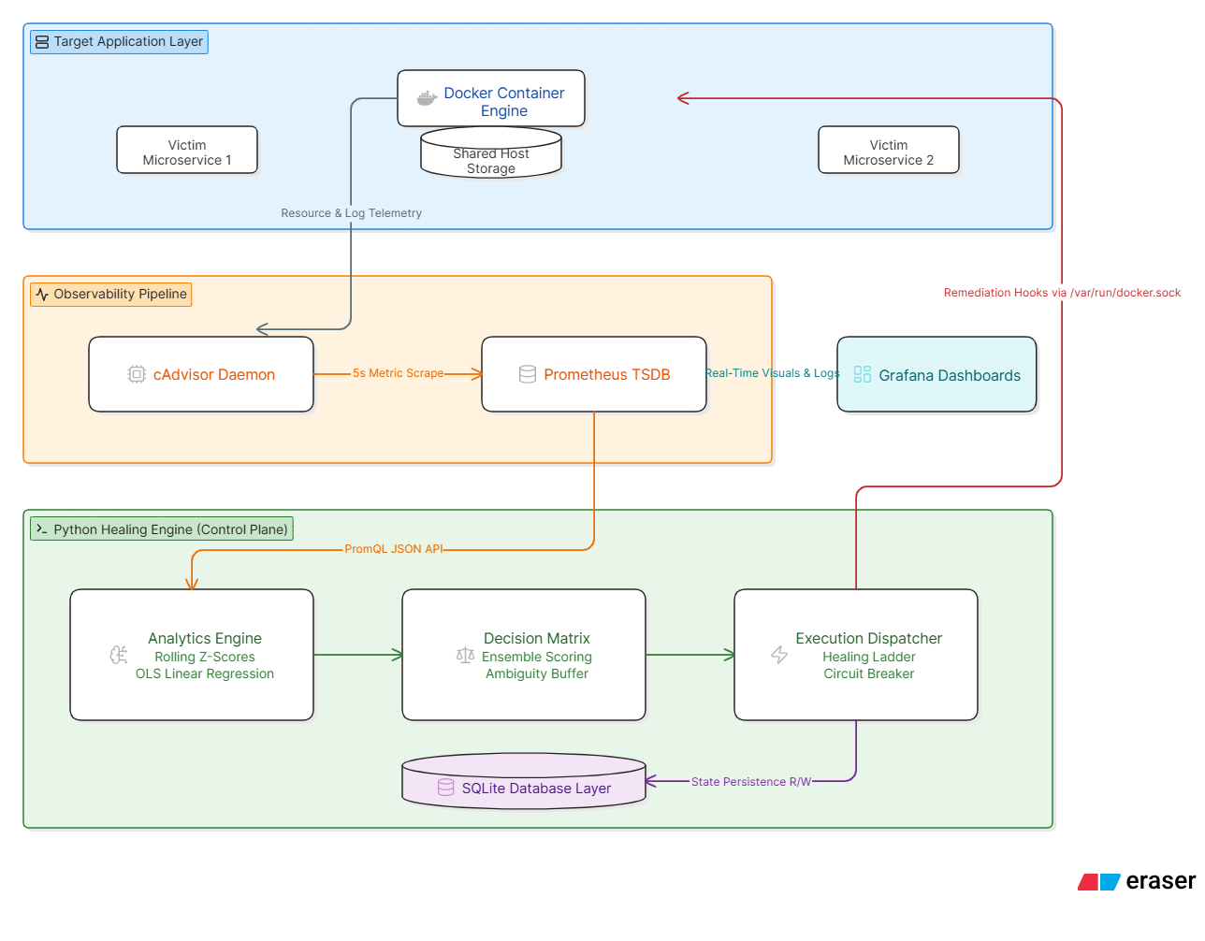

Algorithmic Program Flowchart:
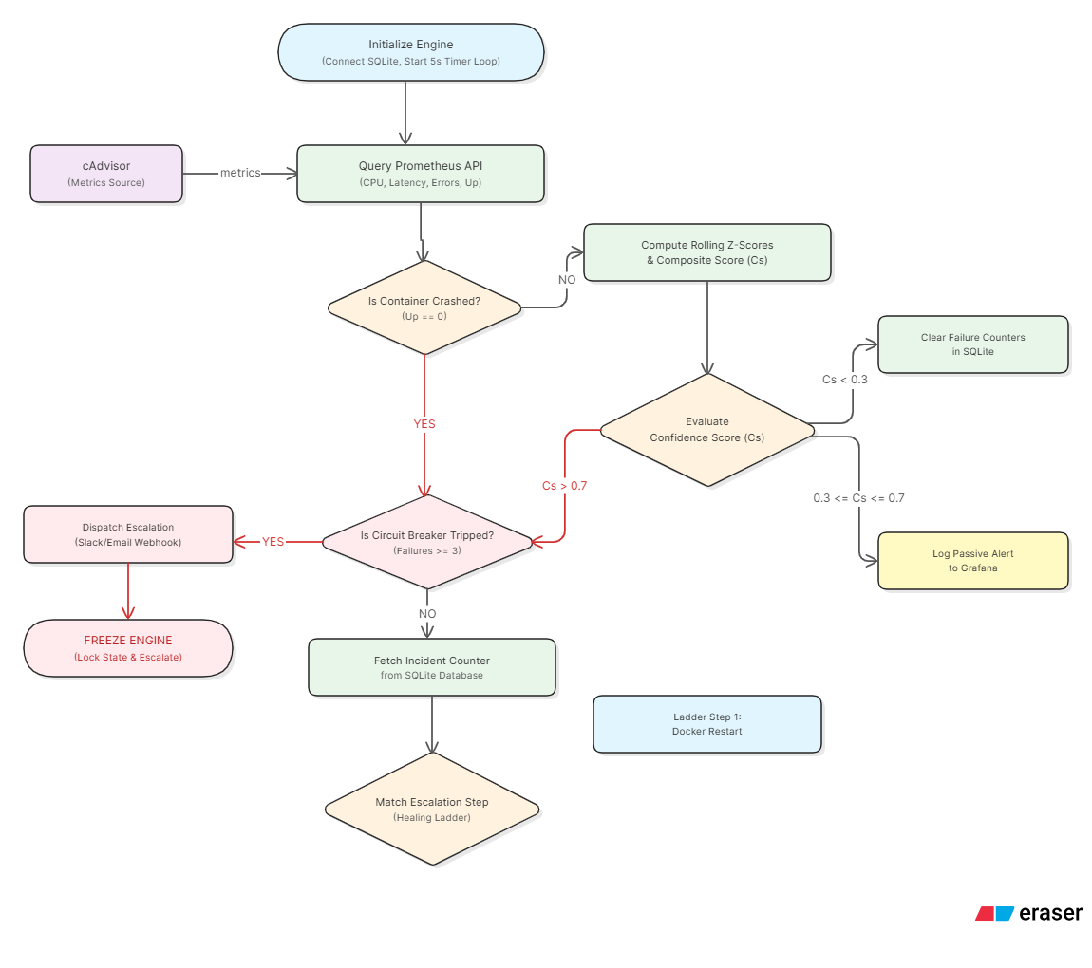

REFERENCES

[1] Laheri, R., Sukumar, H.K.K., Kola, C., Makin, Y. "Self-Healing Infrastructure: Leveraging Reinforcement Learning for Autonomous Cloud Recovery and Enhanced Resilience." Journal of Information Systems Engineering and Management, Vol. 5, Issue 2, 2025. (Validates multi-strategy recovery approaches and provides baseline metrics for MTTR reduction.)

[2] Manohar, N.V., Shukla, R., Abi, S. "Autonomous Multi-Agent System for Integrated SRE and Self-Healing in Cloud-Native Environments." ICSSSM 2025 Proceedings, Atlantis Press, 2025. (Represents the heavy-AI extreme; our project contrasts by using lightweight statistical methods.)

[3] Shevchenko, O. "Self-Healing Infrastructure: Automated Recovery Methods and Their Effectiveness." The American Journal of Engineering and Technology, Vol. 7, Issue 6, 2025. (Provides comparative evaluation of rule-based and ML-based recovery; supports our healing ladder approach.)

[4] Angelis, A., Kousiouris, G. "An Overview on the Landscape of Self-Adaptive Cloud Design and Operation Patterns." arXiv preprint arXiv:2503.06705, 2025. (Identifies a research gap in reliability-focused self-healing; our project addresses this with predictive disk remediation.)

[5] Cloud Native Now. "From PagerDuty to ‘Agentic Ops’: The Rise of Self-Healing Kubernetes." Industry Analysis Report, 2026. (Confirms self-healing as a major 2026 trend; our system provides a lightweight, accessible alternative.)

[6] Prometheus Documentation. "Prometheus Querying and Best Practices." Available at: https://prometheus.io/docs/ (Accessed April 2026). (Essential reference for configuring metric scraping and PromQL queries.)

[7] Docker SDK for Python Documentation. "Docker Engine API Client Library." Available at: https://docker-py.readthedocs.io/ (Accessed April 2026). (Primary library used by the healing engine to execute container actions.)

[8] scikit-learn Documentation. "Linear Regression and Preprocessing." Available at: https://scikit-learn.org/stable/ (Accessed April 2026). (Foundation for implementing predictive disk fill detection and Z-score calculations.)

